A

Project Report on

Book Store Management System

Submitted to

Savitribai Phule Pune University

In the partial fulfillment of the requirement of the award of the degree of

Bachelor of Computer Application – TYBBA(CA) Sem VI

Academic Year 2017-18

By

Vishal Rai

Under the guidance of

Prof. Amit Tale

Through



Alandi (D) - Pune 412105



CERTIFICATE

Department of Computer Application

This is to certify that Mr.Vishal Rai**,** Exam Seat No ----------------. has successfully completed his project work entitled **Book Store Management System** in the partial fulfillment of the requirement of the degree of Bachelor Of Computer Application for the Academic Year 2017-18

Prof. Amit Tale Mrs. Akshada Kulkarni

Project Guide Head Of Department

Internal Examiner External Examiner

**Acknowledgement**

The words are not enough to express my thanks to **Dr. B. B. Waphare**, **Principal, MIT Arts Commerce and Science College Alandi (D)** for providing me with the opportunity to avail the excellent facilities and infrastructure of the institute.

It is my proud privilege to express my profound gratitude to **Prof. Akshada Kulkarni, HOD, Computer Application Department**, for her astute guidance, constant encouragement and sincere support throughout my academic course.

I thanks to my honest gratitude to **Prof. Amit Tale** for her inspiration, constructive suggestions and affectionate guidance in my project work completion.

Last but not the least, I express my sincere thanks to all my dear friends and family members for their constant motivation, moral support and invariable direction throughout my life.

**DECLARATION**

I, **Vishal Rai** hereby declare that this project work entitled **Book Store** Management System submitted at MIT, Arts Commerce and Science College, Alandi(D), (Affiliated to Savitribai Phule Pune University) is a record of original work done by me under the supervision and guidance of Prof. Amit Tale, Department of Computer Application.

Signature:

**Name of Student: Vishal Rai.**

**Exam Seat No.:**

**Place: Alandi(D), Pune.**

**Date:**

**Index**

|  |  |  |
| --- | --- | --- |
| Sr.No | Contents | Page No |
| 1 | Introduction |  |
|  | 1.1 Introduction of System | **6** |
|  | 1.2 Scope of System | **7** |
|  | 1.3 Proposed System | **7** |
| 2 | System Analysis |  |
|  | 2.1Fact findings Techniques | **8** |
|  | 2.2Feasibility Study | **10** |
|  | 2.3 H/w & S/w Requirement | **12** |
| 3 | System Design |  |
|  | 3.1 Entity Relationship Diagram | **13** |
|  | 3.2 Context Level Diagram | **14** |
|  | 3.3 Data Flow Diagram | **15-16** |
|  | 3.4 Data Dictionary | **17-21** |
| 4 | From Design | **22-26** |
| 5 | Report | **27-31** |
| 6 | Advantages & Disadvantages | **32** |
| 7 | Future Enhancement | **33** |
| 8 | Bibliography | **34** |

**INRODUCTION:**

Now a days, there are many company want to develop a software system for Book store Billing System. Because this is, they want to expand scope of their business activities, increase turnover and reduce the cost in time and labor.

Modern Book Store is a General Book Store, which buys and sells the Books as per the requirement of the customer. It has so many dealer ships from which the Books are purchased and also some of the Books it gets directly from the company and some of them from the wholesale retail shops.

For the past few months they are facing difficulties in the current system for tracking down the details of the available and that of the sold due to the increased consumption of the Books.The system solve their difficulties in maintaining the records of the sold ones and that of the available and also to track down the details of the Payments done to the distributors, received from the customers, etc… and also to track down the information of the quantity of the stock available and that of the purchasable.

**Scope:**

Registration of new user and authentication of existing user .A GUI containing text boxes, buttons, drop-down list boxes and labels which will provide a user-friendly interface to the user to work with the application .To allow add a new books, search all information. Edit or change, remove a Books details .To allow add a new customer, distributor, search for information has relationship .To allow add a new order, search for information, update order status Generation of reports has relationship

**Proposed System:**

Create a database for the Books Store Billing System. Add tables to store information about different products, supplier, customers … The manager can to manage and also to track down the details of the Payments done to the supplier, received from the customers, etc… and also to track down the information of the quantity of the stock available and that of the purchasable.

**2. Analysis**

**Fact Finding Technique**

###### Interview

* + Interviews were taken to gather information about the existing system and analysis was done
  + To observe the subject. The user & books were asked many questions about the existing manual system.
* How various customer details are maintained?
* How various doctors details are maintained?
* How to Book process is done?
* How customers Bill is generated?

###### **Record Review:-**

* + - Record review may be performed in the beginning of the study to collect initial information or at end of study to compare actual operations. Information related with the system may be present in the form of records like books, magazines, journals, manuals etc. This kind of record review provides very valuable information to the analysis

###### **Document Search:-**

* + - In order to design proper output Reports and input screens document searching is proved to be an important technique. we searching following document for this.
* Customer registers
* Supplier detail register
* Book Detail register

Feasibility Study

An important outcome of the system investigation is that it is found to be feasible.

#Technical

#Operational

#Economical

* Technical Feasibility

The technical issues usually raised during the feasibility stage of investigation of center around the necessary technology existence, technical capacity of equipment to hold the data require Use the new system, and the technical guaranties of the accuracy, readability, ease of access etc.

The company is equipment with latest of hardware and software including MS-ACCESS 2013 and MS-VISUAL Studio. So the system is technical feasible.

###### **Operational Feasible**

The proposed system is a GUI (Graphical User Interface) application and also user friendly. Buttons are created for various operations. Alerts are prepared for the proper use of the system. There was a need for the development and enhancement of the existing system. Due to the enhancement of the existing manual system most of the difficulties were solved.

###### **Economic Feasibility**

This feasibility is mainly concerned with cost benefit analysis of the proposed system. Financial benefits must equal or exceed the cost. Since the hardware and software support is facilities that are require by the proposed system.

Software Requirement specification

Software requirement:

* **Operating system:-**

Windows all OS

###### **Software:-**

Front End: - Visual Studio 2010

Back End: - Microsoft Access 2013

* **Hardware requirement:-**

Minimum:

* 600 MHz and above processor speed.
* 256 MB Ram.
* Only Color Monitor
* 2 GB and above free space
* Printer

**3. System Design**

**ERD**



**Context Level Diagram**

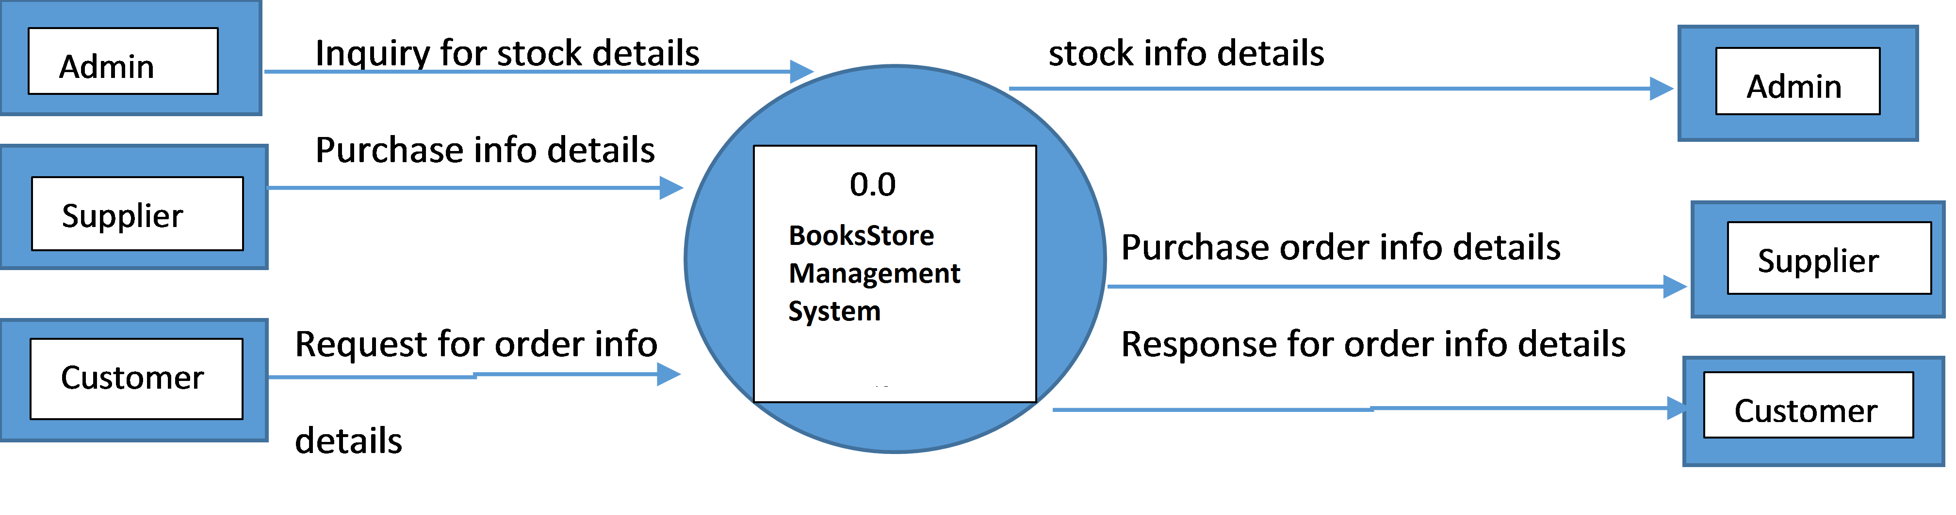

**1st Level DFD**



**2nd Level DFD(4.0 Sales)**



**Data Dictionary**

Data Dictionary

|  |  |  |
| --- | --- | --- |
| Data Flow Name | Type | Description |
| CID | Auto Number | Register Number of Custoemr& Primary key |
| CName | Text | Customer Name |
| Address | Text | Customer Address |
| Email | Text | Register email of customer |
| Phone | Auto Number | Customer Phone |
| Gender | Text | Male,female |

### *Login Table*

|  |  |  |
| --- | --- | --- |
| Data Flow Name | Type | Description |
| User | Text | User Name |
| Pass | Text | Password |

**Customer Bill:-**

|  |  |  |
| --- | --- | --- |
| Data Flow Name | Type | Description |
| Id | Number | Id of bill |
| Sales _Id | Number | Id of Sales |
| Sales_Date | Date/Time | Date of sales |
| Cust_Id | Number | No of customer |
| Cust_name | Text | Name of customer |
| Grossamt | Number | Amount of gross |
| Totalamt | Number | Total amount |
| Paidamt | Number | Total paid amount |
| Balance | Number | Remaining balance |

**Product:-**

|  |  |  |
| --- | --- | --- |
| Data Flow Name | Type | Description |
| Pid | Text | Product number |
| bname | Text | Name of book |
| Publisher | Text | Name of Publisher |
| isbnno | Text | Isbn no of product |
| bdesc | Text | Book description |
| datee | Date/Time | Date |
| Price | Number | Price of product |
| Sales | Number | Total sales |
| quantity | Number | Book quantity |
| author | Text | Book author name |

**Purchase detail:-**

|  |  |  |
| --- | --- | --- |
| Data Flow Name | Type | Description |
| Pur_id | Number | Purchase number |
| Pur_date | Date/Time | Purchase date |
| Sup_id | Number | Supplier no |
| Sup_name | Text | Name of supplier |
| Pro_id | Number | Product no |
| bname | Text | book name |
| isbnno | Text | isbn no |
| Price | Number | Price of product |
| Quantity | Number | No of items |
| Amount | Number | Amount of product |

**SALES :-**

|  |  |  |
| --- | --- | --- |
| Data Flow Name | Type | Description |
| Sales_id | Number | Sales no |
| Sales_date | Date/time | Sales date |
| Cust_id | Number | Customer no |
| Cust_name | Text | Name of customer |
| Pro_id | Number | Product no |
| bname | Text | Name of book |
| isbnno | Number | Book isbn |
| Price | Number | Product price |
| Quantity | Number | No of items |
| Amount | Number | Total amount |

**Supplier bill:-**

|  |  |  |
| --- | --- | --- |
| Data Flow Name | Type | Description |
| id | Number | Book id |
| Pur_id | Number | Purchase id |
| Pur_date | Date/time | Date of purchase |
| Sup_id | Number | Supplier no |
| Sup_name | Text | Name of supplier |
| Totalamt | Number | Total amount |
| Paidamt | Number | Amount paid |
| Balance | Number | Remaining balance |

**Supplier:-**

|  |  |  |
| --- | --- | --- |
| Data Flow Name | Type | Description |
| Sid | Number | Supplier no |
| Sname | Text | Name of supplier |
| Address | Text | Address of supplier |
| City | Text | City of supplier |
| Phone | Number | Supplier phone no |

**GST:-**

|  |  |  |
| --- | --- | --- |
| Data Flow Name | Type | Description |
| Id | Number | Id of Gst |
| Salesid | Number | Sales id |
| GStdate | Date/time | Date of Gst |
| Gstpercent | Number | Percentage of Gst |
| Gstamt | Number | Amount of Gst |

**Project Screen Shot**

# LOGIN FORM

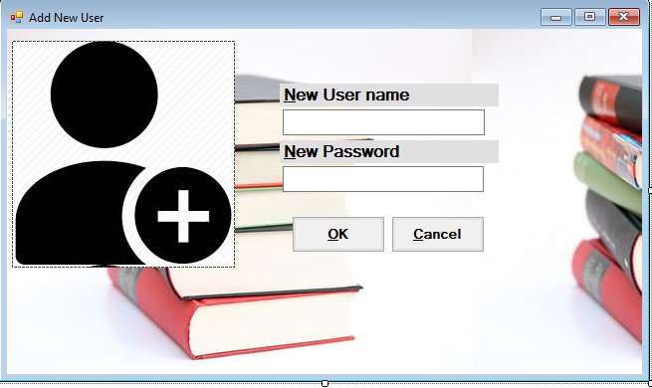

**MAIN FORM:-**



**CUSTOMER INFORMATION:-**

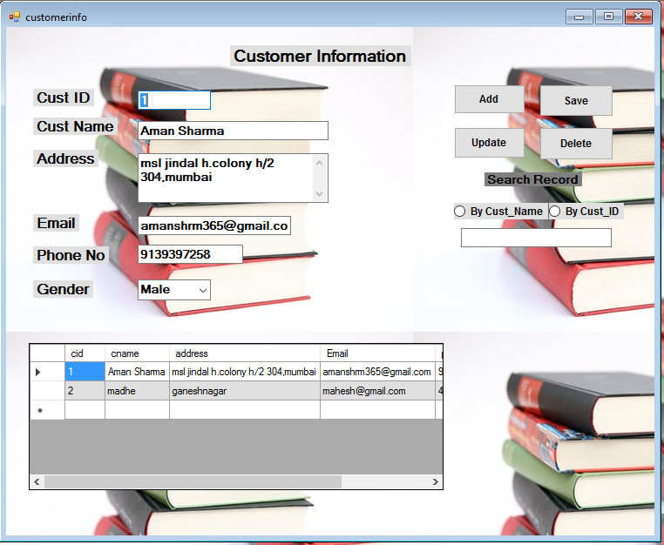

**SUPPLIER INFORMATION:-**

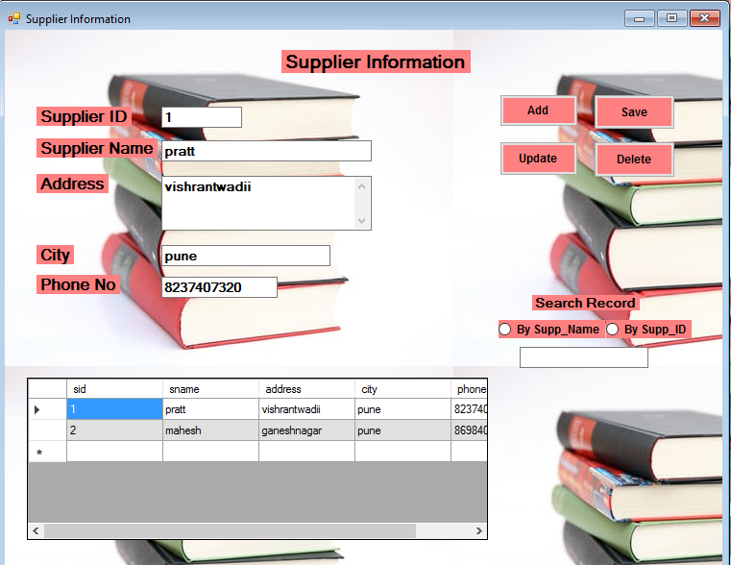**PRODUCT INFORMATION:-**

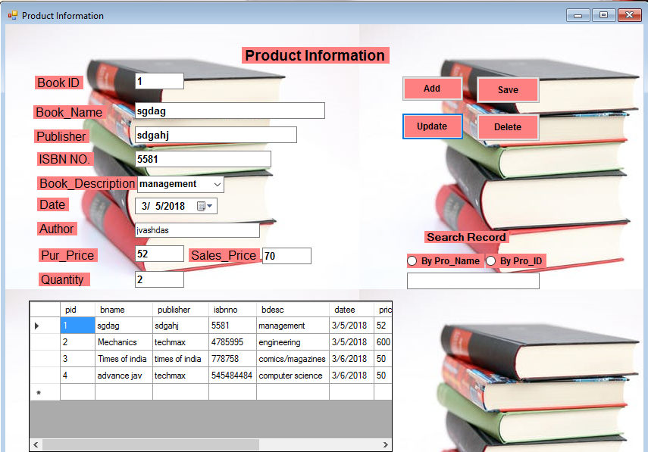

**CUSTOMER SALES EDIT:-**

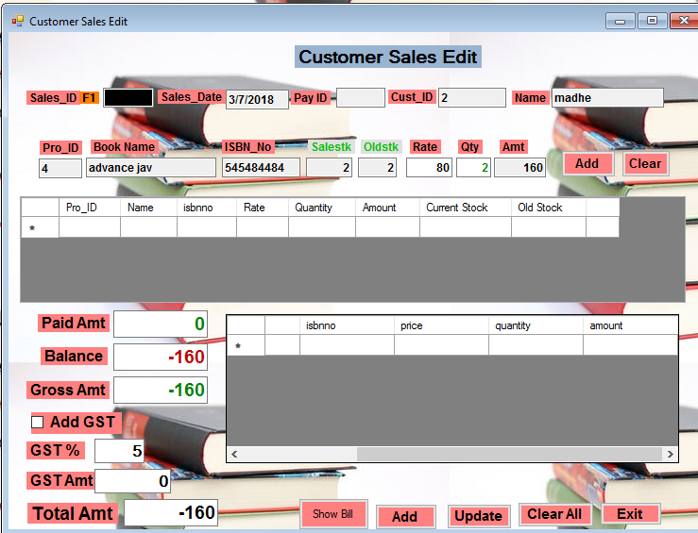

**CUSTOMER..SALES:-** 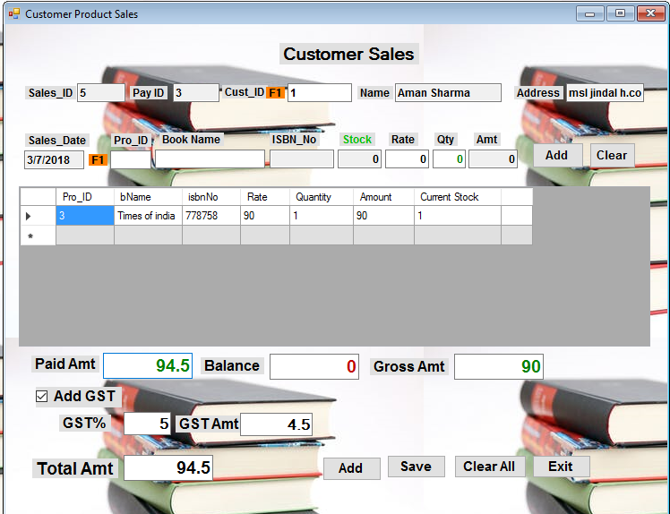

**PRODUCT EDIT:-**

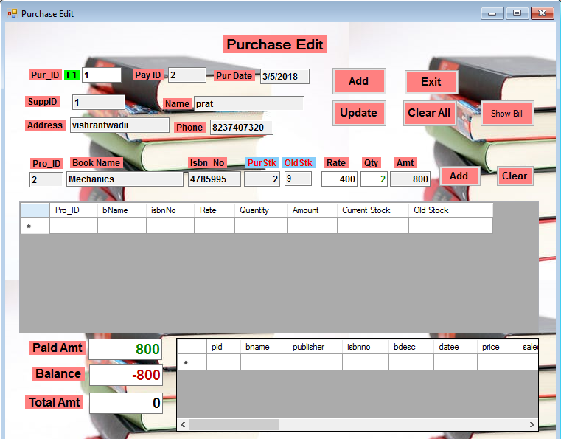**STOCK PURCHASE:-**

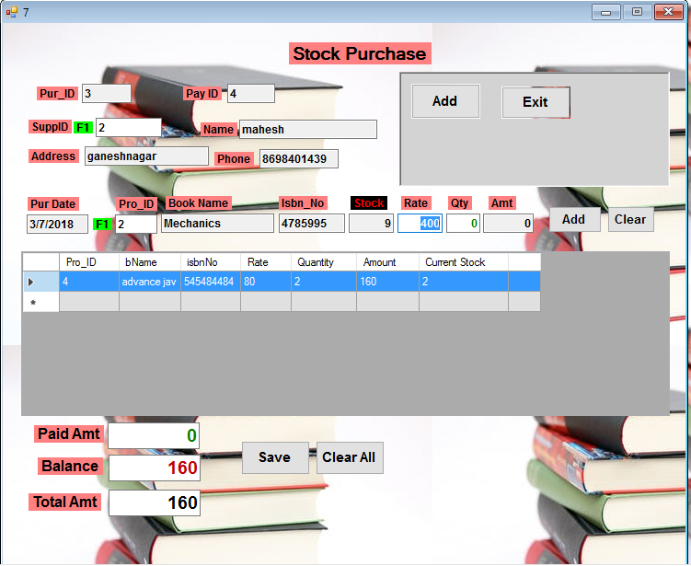

**GST INFORMATION:-**

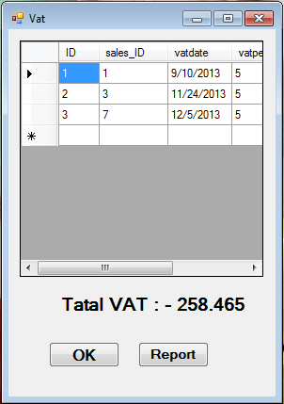

**Reports-:**

# Customer Report

# 

# Total Customer Bill Report

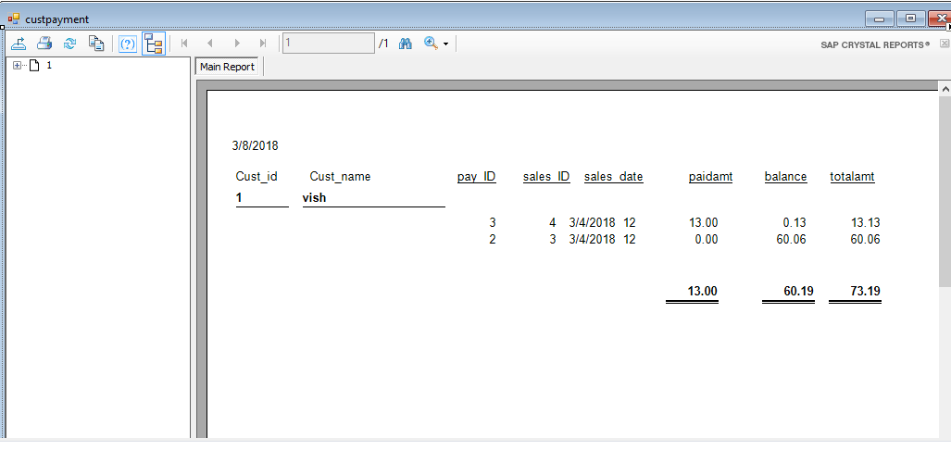

**Total customer Product Sales**

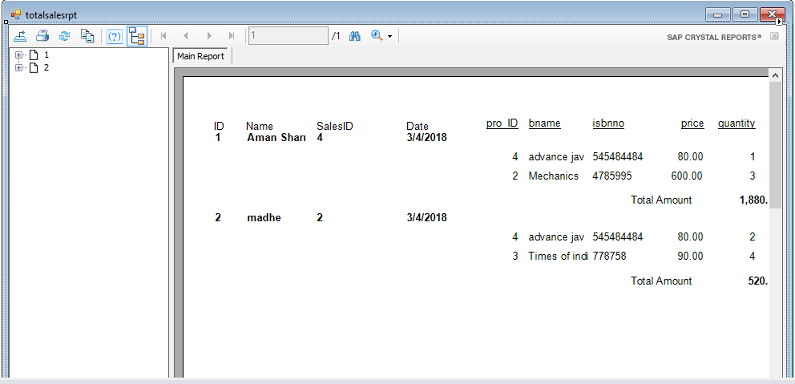

# Product Information Report

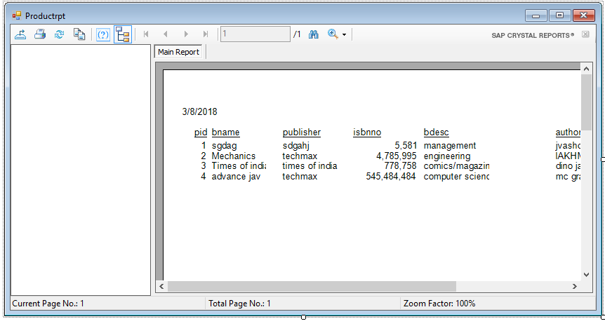

# Total Product Purchase Report

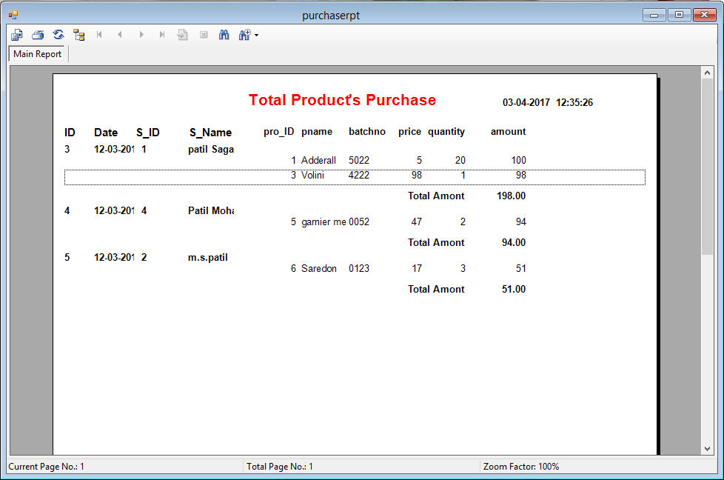

# Total Product Sale Report

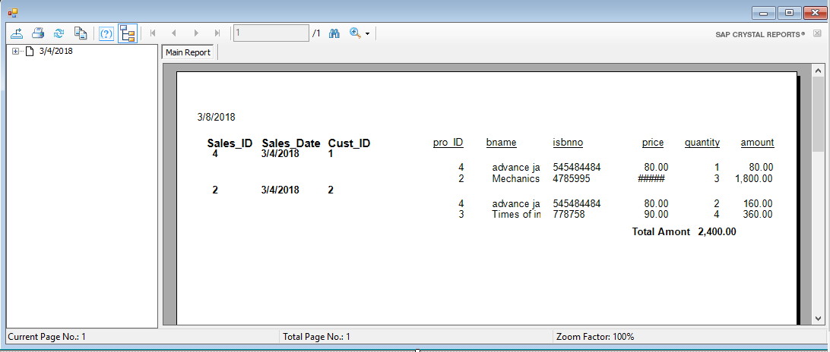

# Supplier Information Report

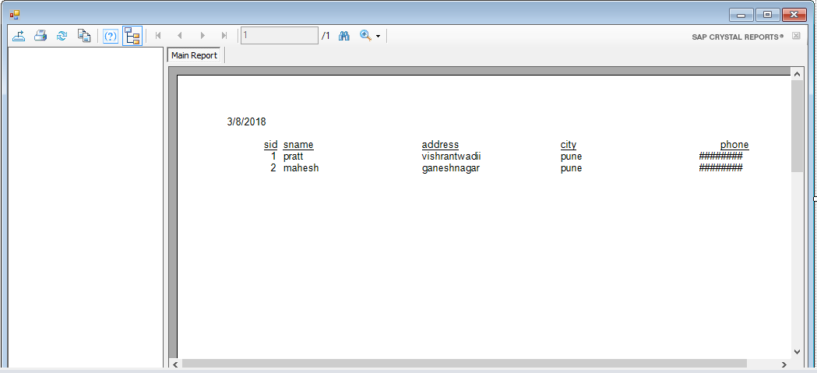

# Total Supplier Bill Report

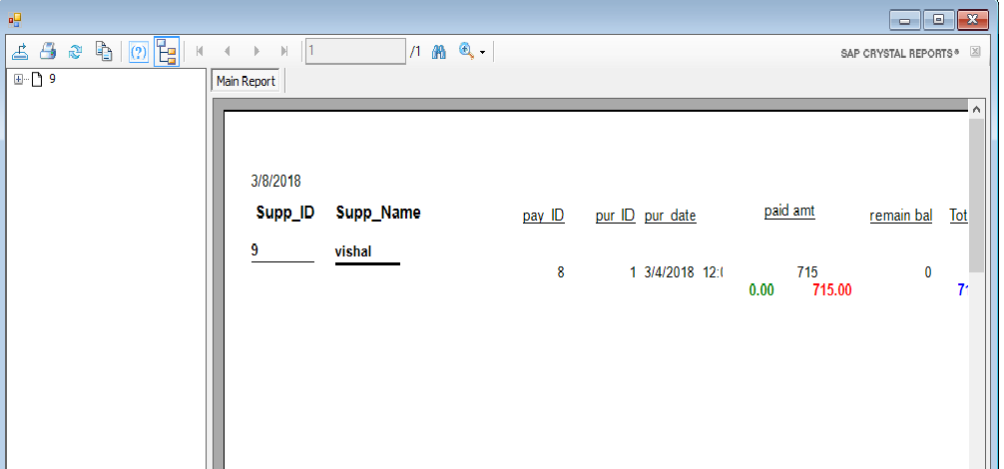

**Advantages Of System:**

* In this system we provide higher security.
* these system consist of book information also like book publisher , book type, author etc.
* this system is user friendly.
* there is no any Ambiguity.
* Can have personal account.

**Disadvantages Of System:**

* While Purchasing online there is possibility of account being hacked or when you select online payment there are chances of loss of personal information and account.
* we provide limited facility to use.

**Future Enhancement**

As any software developed should be always open for changes i.e. any kind of changes made in future should be easily acceptable by the project. Our project “BOOK STORE” intends to provide those features to its users and its further scope of development has been mentioned below.

* To provide a much better and improved interface.
* This project can be enhanced by using Oracle

As a backend in place

* Database can be fully normalized as much as possible.

**Bibliography**

**Website Reference:**

<https://www.Google.com>

www.codeproject.com

Youtube.com